UiPath Best Practices

Overview 4
Purpose 4
Scope 4
Project Structure 5
Project Structure 5
Naming Convention 6
Naming Convention 6
Managing Variables and Configuration 9
Definition of Variables Usage Scope 9
Management of Configuration Information 9
Configuration Management 10
Configuration Types 10
Naming Convention of Configurations 10
Design Principles 11
Breaking the process in smaller workflow 11
Annotating Flowcharts and Sequences 11
Control Settings 11
Credentials 11
Code Reusability 12
Dynamic Selectors 12
Simulate Click Activity 12
Annotations & Comments 12
Usage of Dynamic delays 12
Exception Handling 13
Exception circumvention 13
Exception Handling 13
Invoking Workflows 16
Logging 17
Security 18 UiPath Best Practices
3

Login Info（ID、Password management） 18
Registering login information 18
Using Login Information 19
Orchestrator Best Practices 20
Robots 20
Environments 20
Jobs 20
Log Fields 20
Running Bots in the Background 20
Interacting with Alteryx 21
Frequently Asked Questions 21
Troubleshooting 21 UiPath Best Practices
4

Overview
Purpose
The document provides guidelines for development for a UiPath Bot.
● RPA quality assurance ○ Levelization of RPA granularity
○ Enhance maintainability

● Business stability ○ Joint with subsequent business
○ Inspection of exception

● Security Compliance ○ Avoid security risk
○ Recording, reservation of log

Scope
This document is applied to BOT development by using RPA tool UiPath. UiPath Best Practices
5

Project Structure
Project Structure
A project folder should contain the following information and folders # | Item | Description
1 | Project folder | [Business Name]_[Process Name]  The name of the project folder should convey what department does the process belong to, and what does the process do
2 | XAML files | These are the files which house UiPath code. The files should be broken down into bite sized code addressing the function of the overall process.  ● All the sub processes should be invoked from the Main_[Process Name].xaml file housed in the root directory  ● All the sub processes should be placed in the folder called [xaml_code] ○ The file names for the all the XAML code files should be preceded by a number signifying the order in which the files will be invoked ■ For Example: ● 1_ReadDataExcel.xaml  ● 2_UploadToSFDC.xaml  ● 3_ProcessReport.xaml
3 | Screenshots folder | In unattended bots, the developer can choose to store screenshots of the process upon encountering an exception to facilitate debugging. The Screenshots can be saved in the .screenshots folder.
4 | Template folder | If a process warrants the use of specific templates for Reports, mail, text etc. these should be housed in the Template folder. The templates remain fixed through the process.
5 | Configuration folder | The Configuration folder contains the Configuration file
6 | Config File | Config will contain the initial settings, constants, and Assets required to fetch from the Orchestrator. This file will be housed in the Configuration folder
 | XX(any) folder | Any additional folders that a process might require. The purpose of the folder should be captured in a ReadMe.txt file and placed in the folder  For example, if a UiPath bot invokes an Alteryx workflow, that should be stored in a folder designated for Alteryx workflows
 | JSON file | File to define project properties. (Generated automatically)
Naming Convention
Naming Convention

Item | Naming convention | Sample
XAML file | [describe XAML file].xaml  The name of a XAML file should contain a verb to describe what the module does. This also ensures modularity in the overall automation code | ReadExcelFile.xaml
Project Folder | [Business Name]_[Process Name]  The name of the project folder should convey what department does the process belong to, and what does the process do | CX_ProcessCustomerInvoice
Flowchart | Flowcharts should be named in descriptive text to describe the action being performed  Except for Main, all workflow names should contain the verb describing what the workflow does. | <Flow Chart>: Download SFDC Report
Sequence | Sequences should be named in descriptive text to describe the action being performed  Except for Main, all workflow names should contain the verb describing what the workflow does. | <Sequence> : Get Transaction Data
Activity | Activity names should concisely reflect the action taken, such as “Click the Save Button”.  Keep the part of the title that describes the action (Click, Type Into, Element Exists, etc.). | <Open Browser>: Open Oracle
Variable | Lower camel case namely consists of 2 parts, the first part should describe the type of variable, which should be lowercase. The second part should describe the meaning of a variable, which should capitalize the beginning of the word | Examples for variable naming:  ● strExcelPath (a string variable to store path of an excel file)  ● intRowCount (an int variable to store the total row count)
Argument | Argument names are case sensitive and should have a prefix stating the argument type.  An argument flowing into a workflow should be prefixed with ‘in’, and an argument flowing out of a workflow should be prefixed with ‘out’ | For example:  ● in_strDefaultTimeout  ● in_strFileName  ● out_isTextResult  ● io_intRetryNumber.
Assets | Assets are key pieces of information stored on the UiPath orchestrator. These Assets store information that should be widely available and is managed centrally. Examples of information that can be stored in Assets is key URLs, addresses, or information  The asset name should include [data type]_[definition] | For example:  ● str_SFDCLoginURL  ● str_AutomationIntakeForm
Credentials | Credentials for bot IDs can be stored on a Credential Store for safekeeping and governed usage.  The credential name should include:  ● Username: [BotName]_[application]_UserName  ● Password: [BotName]_[application]_Password | For example:  ● User Name: RPABot001_SFDC_UserName  ● Password: RPABot001_SFDC_Password

Managing Variables and Configuration
Definition of Variables Usage Scope
The disclosure scope of the variable does not apply to the entire process, it’s specified as the minimum scope by the following order.
Activity → Sequence → Flowchart
It is important to consider the logic of the code to dictate the proper scope of the variable. Maintaining the correct scope for the variable allows for cleaner code, faster processing and debugging.

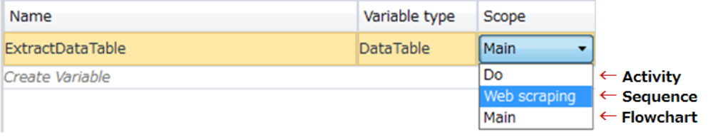
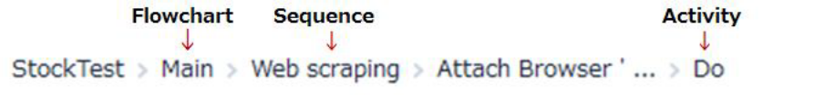

Management of Configuration Information
All the data flowing in from the configuration file should be managed as follows:
● All settings that are used across processes or business units should be stored as Assets in the Orchestrator. These include key URLs, input/output paths, etc. Performing centralized management of such settings allows for quicker change cycles and less confusion
● All credentials should be obtained from the UiPath Orchestrator Credential Stores. This allows for safe storage of the credentials ○ Note: This only applies to bot credentials
○ All user credentials should be stored locally using windows credentials

● If the UiPath robot cannot connect to the Orchestrator, the bot will be unable to obtain the configuration information. In such a scenario a ticket must be raised for the CoE, and reconnection attempts to the Orchestrator should be made

Configuration Management
Configuration Types
The types of configuration are classified into the following three types. These configurations are stored in different tabs in the configuration file. All values in the configuration file are stored using the Camel Case.
Type | Usage pattern
Settings | Store the value which related to business rules by per robot  ● Any change in these setting should not impede the bots performance  ● These settings are generally the ones easily configurable by the User
Constants | These are constant values that do not change often. A few examples of such settings can be ‘Manager’s email address’, ‘Total number of line items to be processed in one go’
Assets | Global settings or constants which are stored in the Orchestrator.

Naming Convention of Configurations

Type | Naming convention | Sample
Settings | [description of the setting] | ProcessFolderPath
Constants | [description of the constant] | ShortDelay, RetryNumber
Assets | [data type]_[definition] | strExcelPath

Design Principles
Breaking the process in smaller workflow
Inculcating modularity into the design and code structure is paramount to good project design. Dedicated workflows allow independent testing of components while encouraging team collaboration by developing working on separate files.
Choose the layout type wisely (flowcharts and sequences).
● If the process workflow has a lot of decision points, a flowchart would be an ideal option. Normally the logic of the process stays in flowcharts while the navigation and data processing is in sequences.
● If the module is linear, using a sequence is always better as it keeps the code simple and readable

By developing complex logic within a sequence, one can end up with a labyrinth of containers and decisional blocks, very difficult to follow and update.
Annotating Flowcharts and Sequences
Since one Flowchart may contain multiple Sequences, it is imperative that all sequences in a flowchart be clearly described and all decision paths should have a description of the decision path
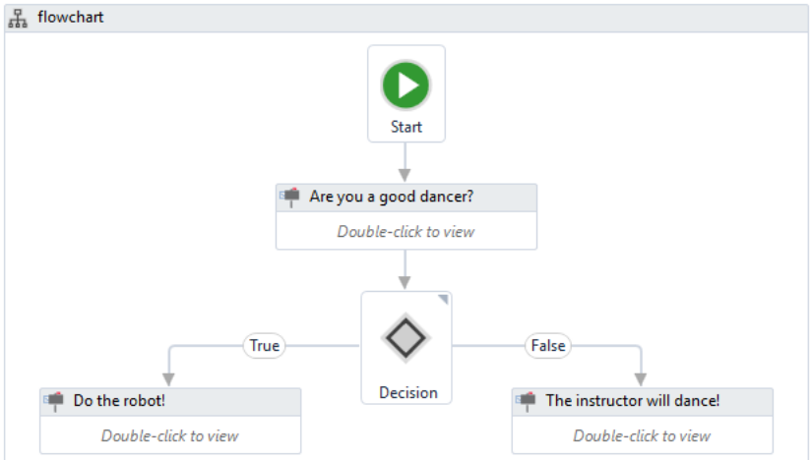
Control Settings
To avoid hard-coding external settings (like file paths, URLs, etc.) in the workflows, we recommend keeping them in a config file (.xlsx, .xml, or .json) or in Orchestrator, as assets, if they change often.
Credentials
No credentials should be stored in the workflow directly, but rather loaded from safer places like local Windows Credential Store or Orchestrator assets. You can use them in workflows via the GetCredential activity.

Code Reusability
When developing, we often need to automate the same steps in more than one workflow/project, so it should be a common practice to create workflows that contain small pieces of occurring automation and add them to the Library.
There is no universal recipe that tells you how to split any given process. However, separation of business logic from the automation components is a good principle that helps with building a code that can be reused effectively.
Dynamic Selectors
A dynamic selector uses a variable or an argument as a property for the attribute of your target tag. This allows the selector to easily identify a target element based on the value of the variable or argument, and not an exact string, which might change, depending on interactions inside your automation project.

A dynamic selector has the following form, with the specifications:
● tag - the target tag, such as <ctrl/>
● attribute - the target attribute, such as name='menuItem'
● {{Value}} - the name of the variable or argument which holds the property of the element you want to interact with

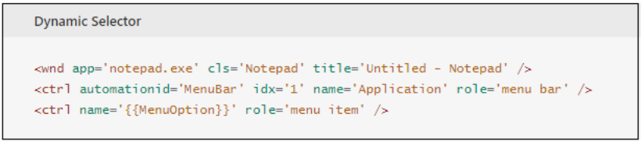
Simulate Click Activity
This activity simulates the click by using the technology of the target application. By default, this check box is not selected. SimulateClick can only be used with the CLICK_SINGLE and BTN_LEFT input types. Otherwise, an error is thrown when executing a workflow.
KeyModifiers cannot be used with the SimulateClick or SendWindowMessages options. No error is thrown when executing a workflow that contains an activity with one of these combinations of options. Hence, it is generally recommended to use the Simulate Type/Click method as it is the fastest of the three and works in the background, but only if you do not need to send special keyboard shortcuts
Annotations & Comments
Right Click on the Activities and add “Annotations”, so that we can describe the logical explanation for that specific activity. Also, "Annotation" should be in the Dock state.
"Comment" Activity is used only when you want to add comments on a series of processes consisting of multiple Activities.
Usage of Dynamic delays
While using Delay activity though the element or image has appeared already it will wait until the mentioned time gets drained. Hence, it is recommended to use dynamic delay activities like:

● ELEMENT EXISTS: if we are waiting for an element to appear.
● IMAGE EXISTS: if we are waiting for an image to appear.
● WAIT IMAGE VANISH if we are waiting for an image to vanish.
● WAIT ELEMENT VANISH if we are waiting for an element to vanish.
● ON ELEMENT APPEAR if we are waiting for an element to appear.

Exception Handling
Exception circumvention
Project | Content
Check input string | When using a user input or a character string obtained from the system as input data, it is checked beforehand whether the character string matches the assumed rule (a type of character string, pattern, blank allowance, etc.).
File/folder presence check | When reading and writing a file, check the presence of the file and the folder before opening the file.
Timeout Setting | Such as when accessing Web sites, how long to wait for a response, implementing timeout settings explicitly.

For an exceptional case that can be assumed, implement an explicit check mechanism in advance to avoid it, to realize Exception circumvention.
Exception Handling
Each process definition body handles assumed errors and handles unexpected errors by the framework.
● Retry Scope - please refer to the UiPath Activity guide for details ○ The purpose of this activity is to retry a process multiple times until it is successful or meets a condition. This activity enables the bot to re-attempt an activity that was not successful x number of times and has a built-in delay which provides increased flexibility when dealing with unstable platforms. It also helps deal with those instances where in-system behavior determines when the bot can move forward (e.g., page needs to successfully load). In contrast, if we used the Try/Catch instead of a Retry Scope, the activities in the Catch block will only execute once. *Note: Only those activities which result in a Boolean value are supported in the Condition Block of a retry scope activity.

● Try-catch - please refer to the UiPath Activity guide for details ○ The purpose of this activity is to: ■ Attempt a process or sub-process that is known / suspected to be unstable and prone to error - be it human or machine caused - and,
■ Attempt to gracefully recover upon exception. As best practice, the “Catch” portion of this activity should not be used to “Retry” the process that failed (i.e. it should not have the same activities as the Try sequence). The “Catch” portion of the code should include

activities that attempt to reset the system and prep it for the next run. Normally, the “Retry” activity should be used to retry a process on exception.

○ Placement ■ Known Exceptions: placement of this activity is most often determined by the developer’s familiarity of ALL KNOWN exceptions. ● For example, if you have a set of activities nested in a For Each Row activity and you KNOW activity 3 has the chance of failing, your Try/Catch should only involve this activity. You should NOT encase the entire For Each Row in the Try/Catch.
● Another example - let’s say you have 3 sub-workflows that support your Main workflow. If you KNOW that an unstable part of the process is in sub-workflow two then your Try/Catch should be around that activity/set of activities within sub-workflow two. The Try/Catch should not be around the invoke activity in the Main workflow that calls sub-workflow two.

■ Unknown Exceptions: there is always a chance that your bot will run into an exception you did not know about. Therefore, as best practice, we need to account for UNKNOWN exceptions that may arise. The main part of your workflow should be enveloped in a Try/Catch using the System.Exception handle. Your write line and logs should clearly annotate that exceptions caught by this main Try/Catch are for unknown exceptions in order to clearly differentiate from the ones you know may occur. This will help with future designs of the Bot code and provide good feedback for the developers who own the platform your Bot is automating against. A good discussion related to this topic can be found here.

https://forum.uipath.com/t/best-practice-do-you-regularly-utilize-try-catch-on-the-whole-workflow/22595

As a general rule, Catches should generally be used to handle exceptions that the bot can recover from. If possible, you should avoid Try/Catch as a normal part of code (exceptions should be exceptional). ● For example, use Element Exists if you know the target of your Click Activity may not be there instead of catching the element not found.

○ Catches to indicate error message thrown ■ It may be difficult to determine the cause of an error when using a Try-Catch. If you put the following Log Message into the Catch component, then the error thrown, and its source will be displayed in the Output pane.

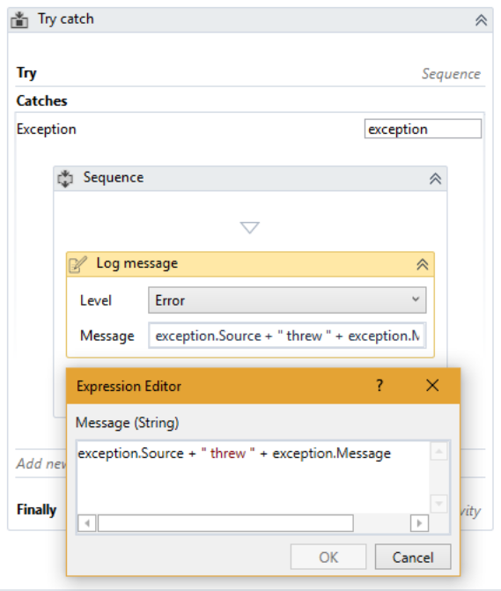

Using the Finally block ■ Activities within the Final block will execute regardless of whether the Try block or Catch block are executed.
■ Use the Finally block to clean up resources, like applications, opened by the bot.

○ Throw activity ■ The throw activity will stop the workflow regardless of where it is in the workflow. ● For example, we can put the Throw activity in the Else block of an If statement and it will throw that error before stopping the workflow.

■ The Throw activity is used to generate an error with your own specifications

● Throw and Rethrow
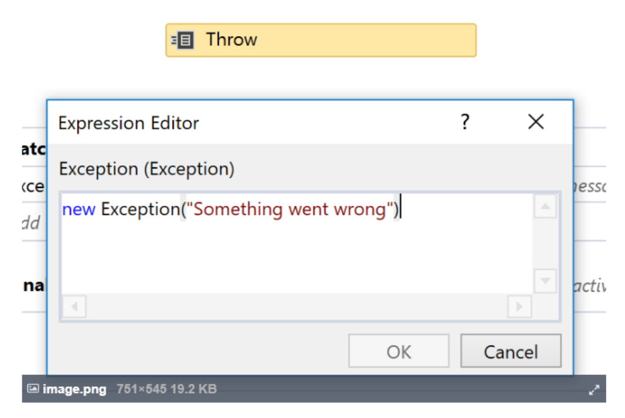

Rethrow activity

UiPath Best Practices
16

■ The Rethrow is commonly used in the Catch block of a Try/Catch.
■ The Rethrow activity will regenerate the original error that caused the workflow to jump to the Catch block.
■ The Rethrow activity is useful if you want to execute certain activities before Rethrowing the original error so it can be bubbled back up the stack.

○ Use the Throw and Rethrow activities to account for your exceptions. Avoid catching exceptions and not doing anything with them - that puts your bot in an unstable state where you can no longer be sure where the process is and if it is safe to continue.
○ Consider serializing the exception if you are not propagating the exception (Newtonsoft.Json.JsonConvert.SerializeObject(ex)), and logging that, so that you don't lose information (stack trace, exception type).

Invoking Workflows
● Invoked workflows should be constructed in such a way so that they can be reused inside of one project or between different projects ○ Invoked workflows should be independently testable
○ Use arguments instead of hardcoded values in invoked workflows
○ Reusable components should be identified and separated into workflows (Invoked workflows) ■ Use the DRY approach (Don’t Repeat Yourself)

● Bots with multiple versions ○ If you have multiple versions of your bot, create a main workflow that prompts the user to select which version of the bot to use and invoke the version of the bot selected

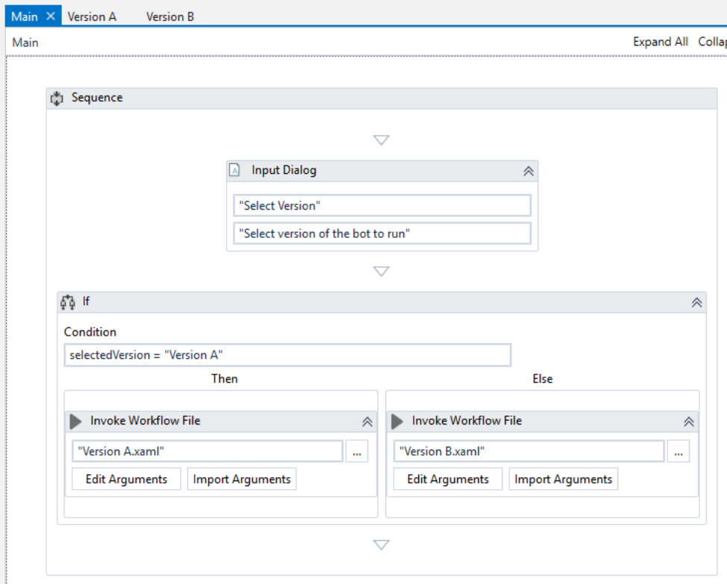

Logging
Using "Log Message" Activity for log output. Log output timing, log level, output format is defined by following forms.
Log Level | Orchestrator Monitored object |  | Description |  | Output standard
Verbose | Non-target |  | Logs a message for both the activity start and end, plus the values of the variables and arguments that are used. |  | Optionally output by the developer during development
Trace |  | Non-target |  | These logs are for developers/testers to actually see at what point/activity the process threw an exception.
Info | Non-target |  | Logging anything ranging from what you want to convey or capture in the logs other than errors or warning. |  | Refer to Figure 10.2’s log output method
Warn | Non-target |  | Logs a warning message to the user which may not stop the execution of a process but informs about a deviation in an otherwise normal process. |  | When post-processing is performed at the occurrence of an assumed business error
Error | Target |  | Logs an error. The robot will attempt to recover and move on with the next item. |  | Unexpected system error
Fatal | Target |  | The robot cannot or should not recover from this. Something has  gone critically wrong, and the workflow needs to be stopped. |  | Same as above

Log Level | Default Logs | User Defined Logs
Verbose | All messages logged with Trace level and Workflow Tracking logs. | All messages logged with Trace level.
Trace | All messages logged with Trace level or higher. | All messages logged with Trace level or higher.
Information | All messages logged with Information or higher. | All messages logged with Information or higher.
Warning | All messages logged with Warning or higher. | All messages logged with Warning or higher.
Error | All messages logged with Error level or higher. | All messages logged with Error level or higher.
Critical/Fatal | All messages logged with Critical level or higher. | All messages logged with Critical level or higher.

Security
Login Info (ID, Password management）
Login information used in business is not defined within each process definition body but is managed using the Credential Store.
Registering login information
Login information used in business is registered and managed by the Asset function provided by Orchestrator. Also, login information is defined individually, not common to all Robots.

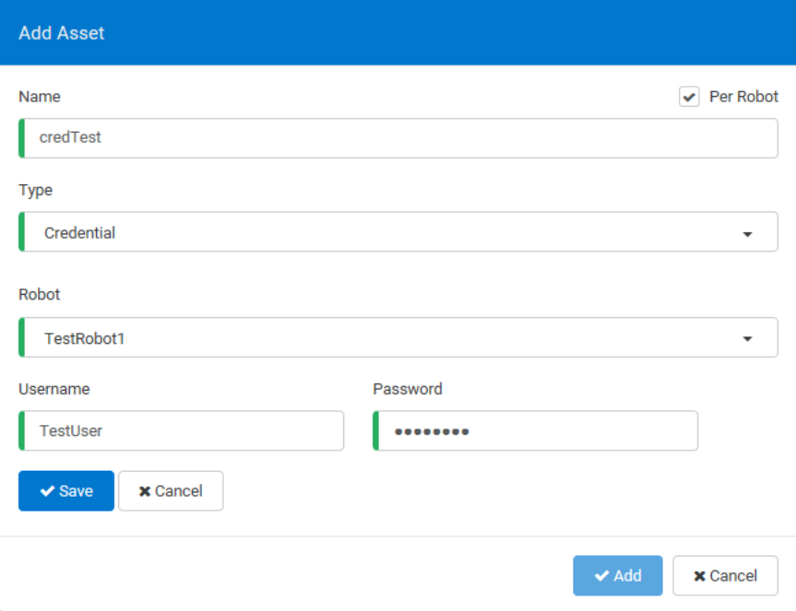
Using Login Information
Acquisition of login information is performed on the framework side and stored in the data table, so in each process definition body, necessary values are acquired and used in the data table.
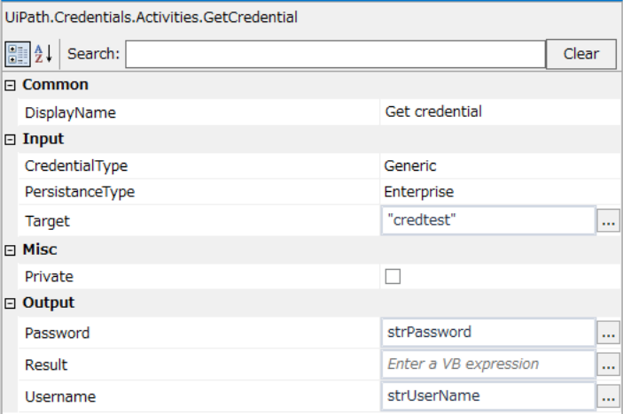

Orchestrator Best Practices
Robots
● Use meaningful names and descriptions for each provisioned Robot.
● For Unattended Robots, the Windows credentials are needed in order to run unattended jobs on them. For Attended Robots, credentials are not needed because the jobs are triggered manually by human agents, directly on the machine where the Robots are installed.
● Every time a new Robot is provisioned, the type of the Robot should be chosen accordingly.
● The next step after registering the Robot to Orchestrator is to check if its status is Available, in the Robots page.

Environments
● Use meaningful names and descriptions for each environment created.
● Orchestrator Environments should map the groups of process execution. Each environment should have a specific role in the company business logic.
● If a Robot is going to execute two different roles, it can be assigned to multiple environments.
● Access management between Robots and processes is done by using Environments properly.

Jobs
● If the Robot needs to run multiple processes with no interruption, all the jobs should be triggered one after another even if the Robot is busy. These jobs go in a queue, with the Pending status, and when the Robot is available again, Orchestrator triggers the next job
● A job while in action should be Stopped rather than Kill.
● The Kill button sends a Kill command to the Robot. This should be used only when needed, because the Robot might be right in the middle of an action.

Log Fields
● The Add Log Fields activity from UiPath Studio, adds more arguments to Robot logs for a better management
● The Log Message activity also logs the previously added fields.

Running Bots in the Background
Here are some tips and tricks to building bots that run entirely in the background:
● Avoid making your window “active”, to prevent the bot from "stealing" control while working.
● Avoid maximizing your window, as the bot does not require a visible user interface to function. ○ Minimize the window right after opening a web page or application, to keep it out of the user’s way. You can use a debug variable to keep it open for development purposes

● Use the "simulate" flag with click and typing activities so that the target element does not have to be active and there is no interference between the bot input and user input
● Use the "private" flag for web browsers so that your current work does not interact with the bot’s work. The general idea is to prevent mutual interference through isolation. This also allows for more predictable behavior on login screens
● Use scope activities (application scope, open web page) to limit conflict with what the user is doing.
● Front load required user interaction (dialog boxes, etc.) so that the bot is, as much as possible, “fire and forget”
● Clean up opened applications/web page, by using Try/Finally block to close application windows
● Avoid using the following image-based activities as they will not work on minimized windows (as the image of the application is not actually rendered)

OCR
○ Screen Shot
○ Click Image

● Avoid using the Wait for ready attribute, as it does not work in background scenarios. Try using the element exists or on element appear activities instead. The same also applies to pixel offsets on clicks

